**Ideation Phase**

|  |  |
| --- | --- |
| Date | 16 June 2025 |
| Team ID | LTVIP2025TMID55215 |
| Project Name | ResolveNow : Your Platform For Online Complaints |
| Maximum Marks | 4 Marks |

**Brainstorm & Idea Prioritization Template**

**Brainstorm & Idea Prioritization Template:**

Brainstorming fosters an open and inclusive environment where every team member is encouraged to contribute their ideas freely. It emphasizes generating a large number of ideas rather than focusing solely on their quality at the outset. Unconventional and innovative thoughts are welcomed and explored collaboratively, allowing team members to build upon each other's suggestions and collectively develop a wide range of creative solutions.

**Step-1: Team Gathering, Collaboration and Select the Problem Statement**

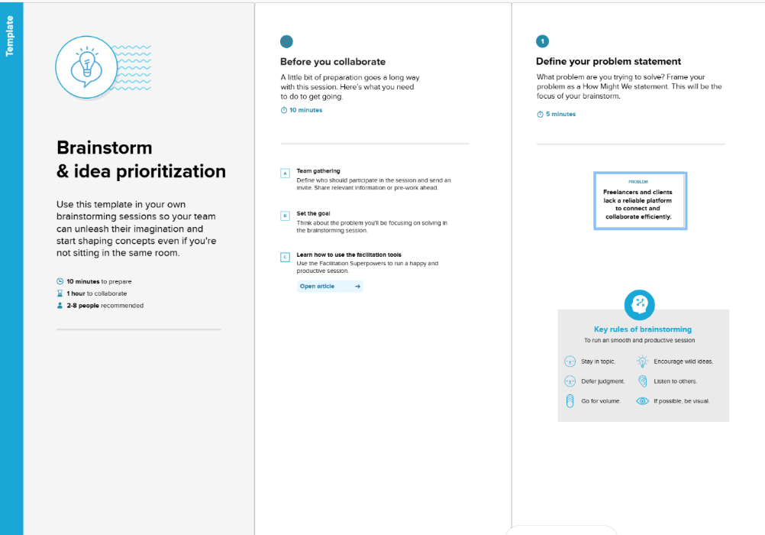

**Step-2: Brainstorm, Idea Listing and Grouping**

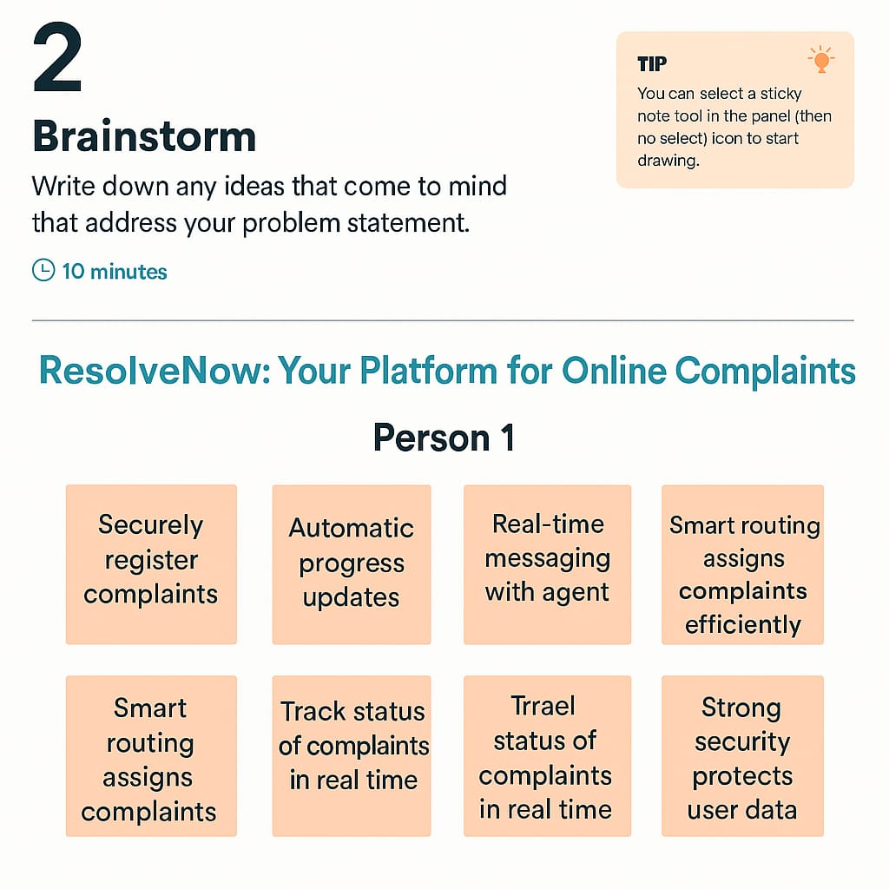

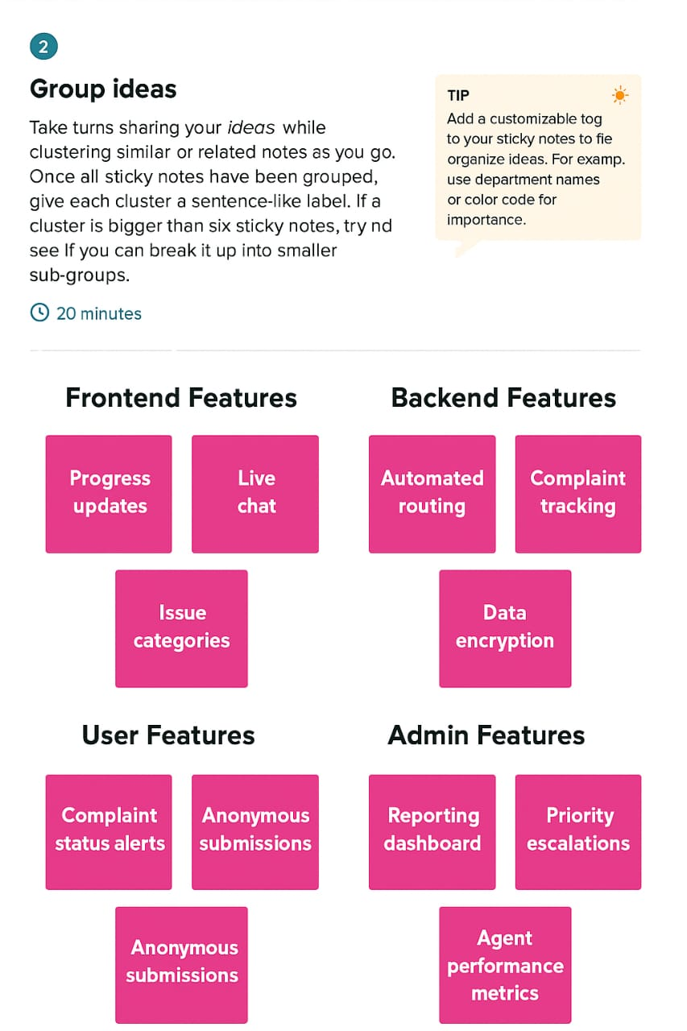

**Step-3: Idea Prioritization**

